|  |  |
| --- | --- |
| Date | 19 September 2022 |
| Team ID | NM2023TMID05031 |
| Project Name | Solar Panel Forecasting |
| Maximum Marks | 4 Marks |

# Brainstorm

**TIP**

Add customizable tags to sticky notes to make it easier to find, browse, organize, and categorize important ideas as themes within your mural.

**TIP**

You can select a sticky note and hit the pencil [switch to sketch] icon to start drawing!

**TIP**

Participants can use their cursors to point at where sticky notes should go on the grid. The facilitator can confirm the spot by using the laser pointer holding the **H key** on the keyboard.

## Before you collaborate

A little bit of preparation goes a long way with this session. Here’s what you need to do to get going.

**10 minutes**

**1**

## Define your problem statement

What problem are you trying to solve? Frame your problem as a How Might We statement. This will be the focus of your brainstorm.

**5 minutes**

**PROBLEM**

Solar power works by converting energy from the sun into power. There are two forms of energy generated from the sun for

**2**

## Brainstorm

Write down any ideas that come to mind that address your problem statement.

**10 minutes**

**3**

## Group ideas

Take turns sharing your ideas while clustering similar or related notes as you go. Once all sticky notes have been grouped, give each cluster a sentence-like label. If a cluster is bigger than six sticky notes, try and see if you and break it up into smaller sub-groups.

**20 minutes**

**4**

## Prioritize

Your team should all be on the same page about what's important moving forward. Place your ideas on this grid to determine which ideas are important and which are feasible.

**20 minutes**

## After you collaborate

You can export the mural as an image or pdf to share with members of your company who might find it helpful.

**Quick add-ons**

# & idea prioritization

Solar-powered Weather Station: Develop a solarpowered weather station that measures and records temperature, humidity, and solar radiation.

Students can analyze the data collected and study the impact of solar energy on weather patterns.

### Use this template in your own brainstorming sessions so your team can unleash their imagination and start shaping concepts even if you're not sitting in the same room.

**A Team gathering**

Define who should participate in the session and send an invite. Share relevant information or pre-work ahead.

**B Set the goal**

Think about the problem you'll be focusing on solving in the brainstorming session.

**C Learn how to use the facilitation tools**

Use the Facilitation Superpowers to run a happy and

our use – electricity and heat. Solar power forecasting is the process of gathering and analysing data in order to predict solar power generation on various time horizons. Solar power forecasts are used for efcient management of

#### Boomika

Data Sources: Gather historical weather data, solar irradiance data,

and solar panel performance data. Consider incorporating realtime weather data sources for accurate prediction.

**Ganesh**

Feature Engineering: Extract relevant features such as temperature, cloud cover, and time of day to improve prediction accuracy. Consider incorporating geographical data, shading effects, and panel degradation rates.

#### Dhaneshbar

Evaluation Metrics:

Defne appropriate

evaluation metrics,

such as RMSE (Root Mean Square Error) or

MAE (Mean Absolute

Error), to assess the

model's performance.

#### Haja Aynudeen

Sustainability: Consider the environmental impact of solar energy and how accurate forecasting can contribute to sustainable energy practices

**+ A Share the mural**

**Share a view link** to the mural with stakeholders to keep

Ensure the data used for forecasting is accurate and reliable. Prioritize data collection and cleaning to minimize errors in predictions.

them in the loop about the outcomes of the session.

**B Export the mural**

Export a copy of the mural as a PNG or PDF to attach to emails, include in slides, or save in your drive.

Prioritize the accuracy of forecasts to optimize energy production and grid integration.

**10 minutes** to prepare

**1 hour** to collaborate

**2-8 people** recommended

productive session.

[**Open article**](https://support.mural.co/en/articles/2113740-facilitation-superpowers)

Historical Analysis: Analyze historical data to identify patterns and seasonal variations in solar panel performance.

Look for correlations between weather conditions and energy output.

Continuous Improvement: Implement a feedback loop to continuously train and refne the forecasting model as more data becomes available.

Integration with Energy Systems: Explore integration options with energy management systems to optimize energy consumption based on forecasts.

the electric grid and for power trading

#### Key rules of brainstorming

To run an smooth and productive session

#### Keep moving forward

**Strategy blueprint**

Define the components of a new idea or strategy.

[**Open the template**](https://app.mural.co/template/e95f612a-f72a-4772-bc48-545aaa04e0c9/984865a6-0a96-4472-a48d-47639307b3ca)

**Customer experience journey map**

Understand customer needs, motivations, and

Stay in topic.

Defer judgment.

Encourage wild ideas.

Listen to others.

#### Importance

If each of these tasks could get

Machine Learning Models: Explore machine learning algorithms like regression, time series analysis, and deep learning for forecasting. Implement a neural network model or use traditional statistical methods like ARIMA.

Solar energy is nothing but the radiant energy emitted by Sun. We may convert this solar energy into electricity either directly using photovoltaic (PV), or indirectly using concentrated solar power (CSP) with the help of lenses or mirrors and tracking systems to focus a large area of sunlight. This solar energy is mainly useful in solar street lights, auto solar irrigation systems, trafc junction signal lighting, etc

obstacles for an experience.

[**Open the template**](https://app.mural.co/template/b7114010-3a67-4d63-a51d-6f2cedc9633f/c1b465ab-57af-4624-8faf-ebb312edc0eb)

Go for volume. If possible, be visual.

done without any difficulty or cost, which would have the most positive impact?

**Strengths, weaknesses, opportunities & threats**

Identify strengths, weaknesses, opportunities, and threats (SWOT) to develop a plan.

Balance the project's budget to make it cost-effective in terms of hardware, software, and personnel.

Implement a system for real- time monitoring and updates to adapt to changing weather conditions

|  |  |
| --- | --- |
|  |  |
|  |  |

[**Open the template**](https://app.mural.co/template/6a062671-89ee-4b76-9409-2603d8b098be/ca270343-1d54-4952-9d8c-fbc303ffd0f2)

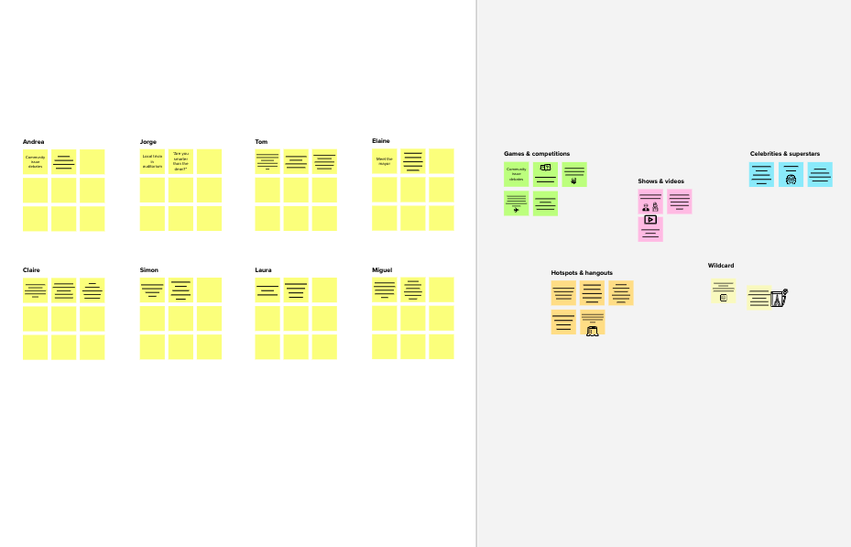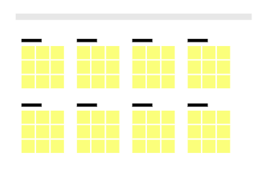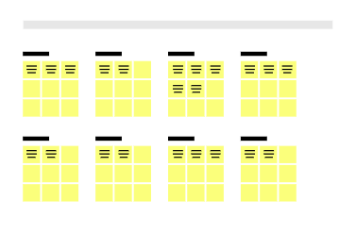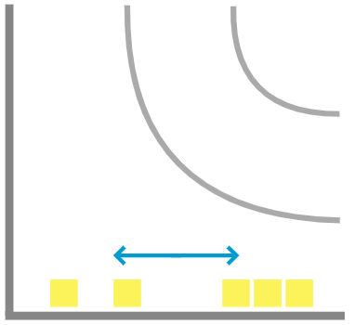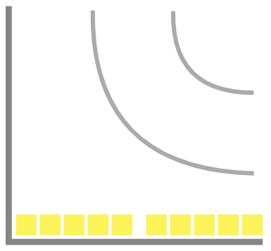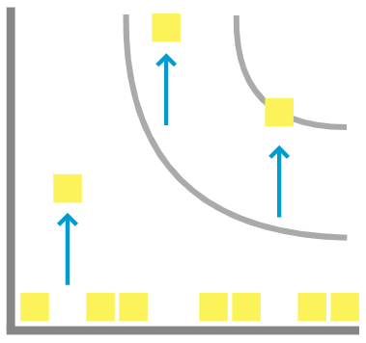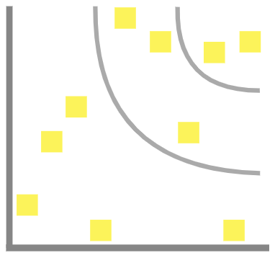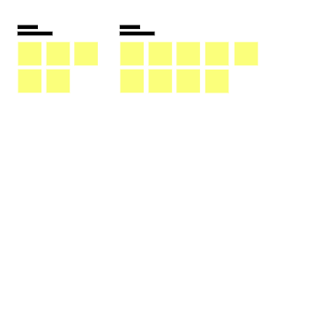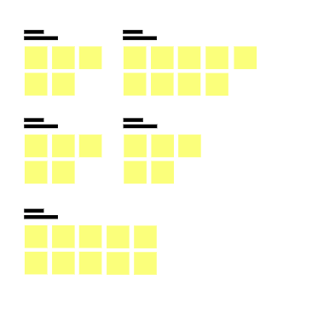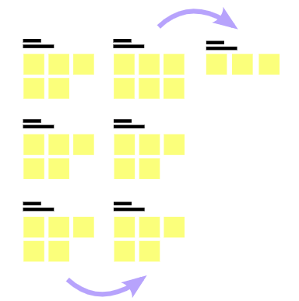

**Template**

[**Share template feedback**](https://muralco.typeform.com/to/CiqaHVat?typeform-source=app.mural.co)

**-**

#### - Feasibility +

Regardless of their importance, which tasks are more

feasible than others? (Cost, time, effort, complexity, etc.)

**Need some inspiration?**

See a finished version of this template to kickstart your work.

[**Open example**](https://app.mural.co/template/e5a93b7b-49f2-48c9-afd7-a635d860eba6/93f1b98d-b2d2-4695-8e85-7e9c0d2fd9b9)